**CityU ranked as the best institution in Hong Kong in terms of ROAR scores**

A recently published paper entitled “Creating Relevance of Accounting Research (ROAR) Scores to Evaluate the Relevance of Accounting Research to Practice” brought good news for the Department of Accountancy. ROAR scores provide an evidence-based evaluation of how relevant academic accounting research is to practitioners by identifying research articles, authors, journals, and accounting topics and methodologies that are producing practice-relevant scholarship.

City University of Hong Kong (CityU) was ranked 16th in the world in the category of “All Institutions” (Table 1a) and 12th in the world in the category of “Institutions with More than 10 Contributions” (Table 1b). Prof. Jeong-Bon Kim, Department Head, ranked second in the world in the overall ranking, first for financial accounting and seventh for Managerial Accounting (Table 2).

Congratulations to the Department and Prof. Kim for their outstanding research achievements! We look forward to continued progress and even more influential achievements from our excellent research faculty in the near future!

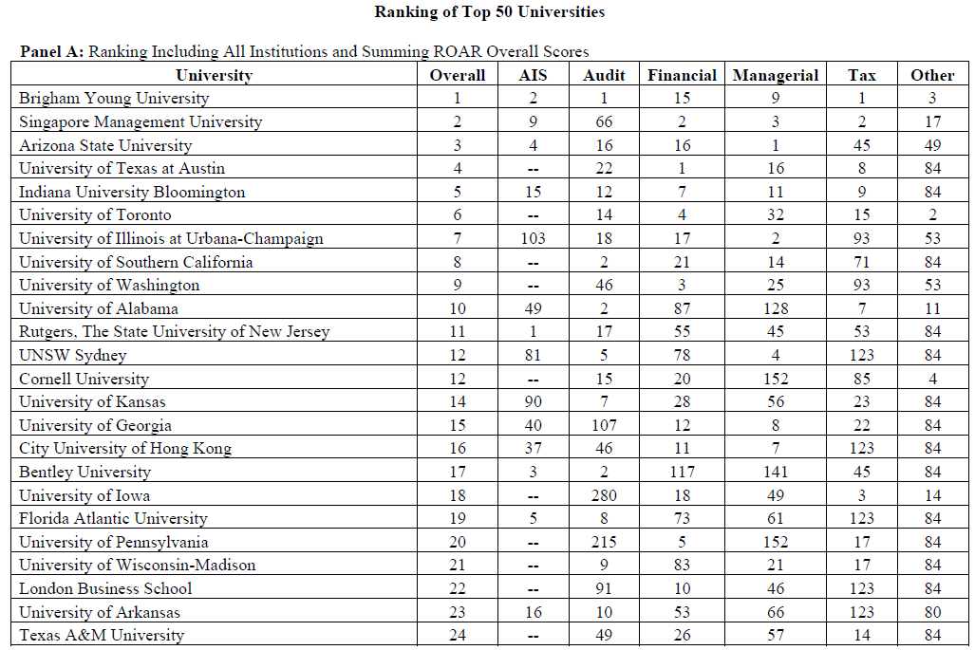

*Table 1a (extracted from paper)*

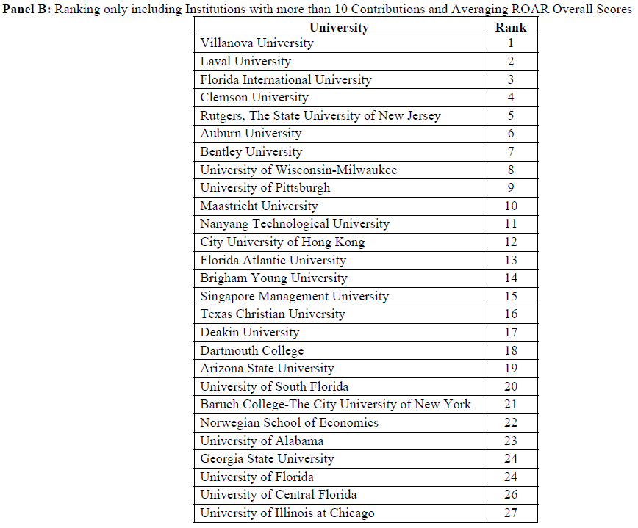

*Table 1b (extracted from paper)*

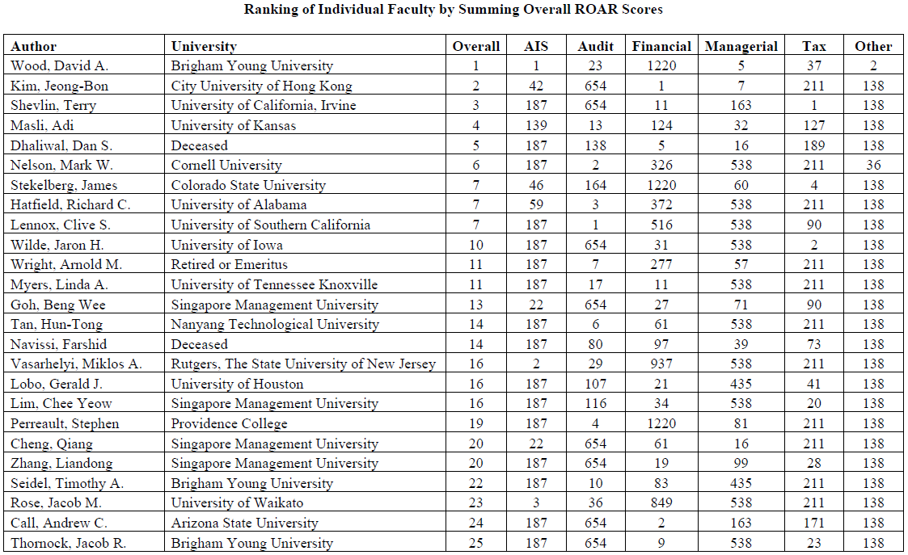

*Table 2 (extracted from paper)*